Laboratory chemical inventory validation
1.Problem:
Analyse chemical inventory records using storage categories, maximum quantities, and compatibility restructions ; that invalid combinations.
2.Objectives:
To validate quantity limits , to check compatibility of chemicals.
3.Assumption:
Acid max 5L
Base max 5L
Toxic max 2L
Acid + Base cannot be together
4.Assumption:
Start input chemical
Category quantity
If category =acid quantity >5 invalid
If base and quantity >5 invalid
If toxic and quantity >2 invalid
Check compatibility acid +base invalid
End
5.Pseudo code:
Read category
Quantity if category =acid and quantity >5
Print(invalid)
Else if category =base and quantity>5
Print(invalid)
Else
Print(valid)
If chem1 = acid and chem = base]
Print(invalid combination)
6.Test cases:
1.t1 | Acid 6L | Invalid
2.t2 | Toxic 1L | Valid
3.t3 | Shelf acid+base
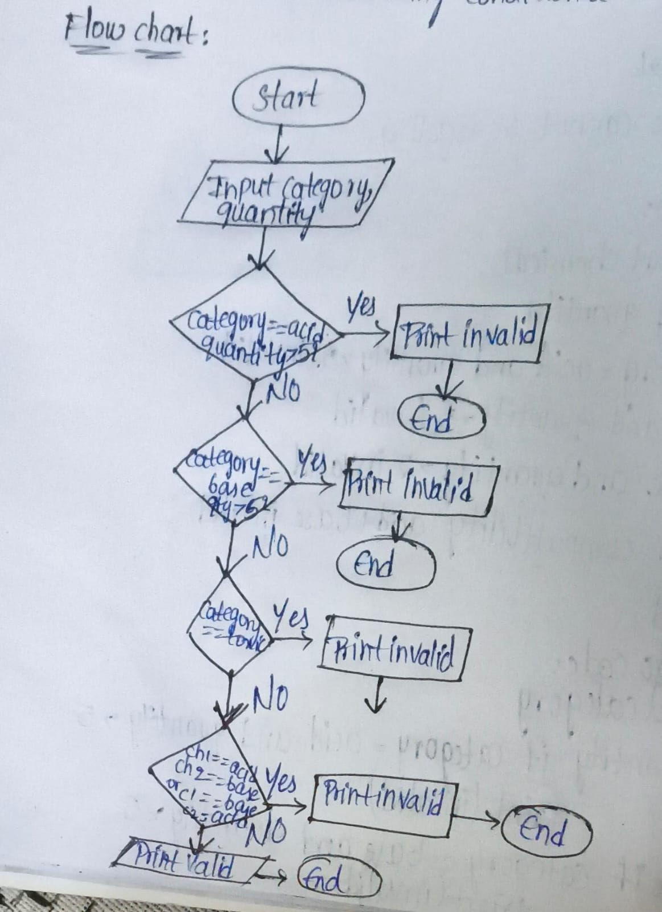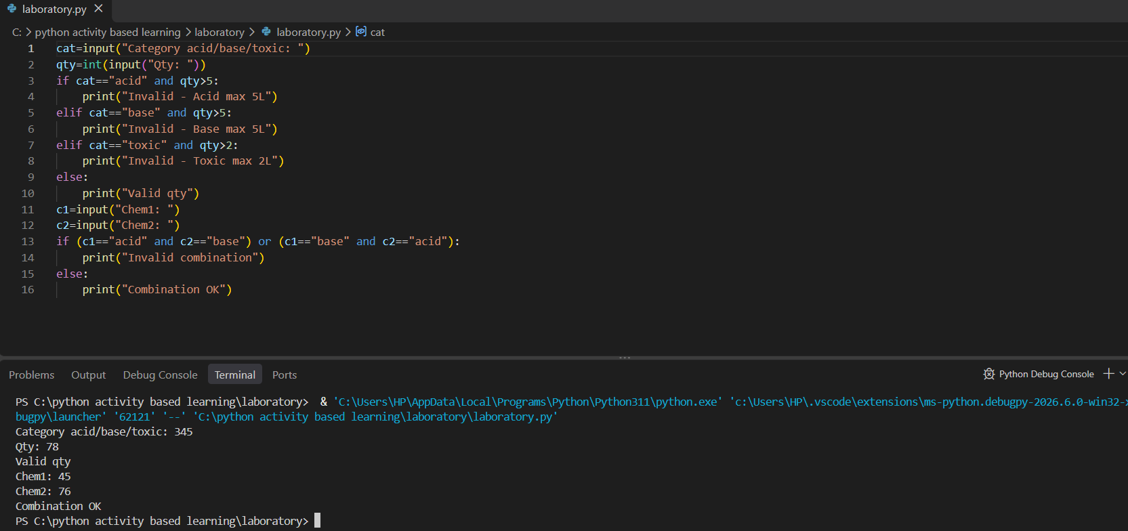
Conclusion:
Chemical validation done using conditional statements.

